DVD Shop Website

# Quick Start Guide

Version 1.0

Document Revision History

| Version Number | Date | Author/Owner | Description of Change |
| --- | --- | --- | --- |
| 1.0 | 2021/11/11 | Romesh Jayawardene | Initial version |
|  |  |  |  |
|  |  |  |  |
|  |  |  |  |
|  |  |  |  |
|  |  |  |  |
|  |  |  |  |
|  |  |  |  |
|  |  |  |  |
|  |  |  |  |
|  |  |  |  |

Table of Contents

1.1 Introduction 4

1.2 Home Page 4

1.3 Browse for movies or TV series 5

1.4 Filtering titles 6

1.5 Searching by keyword 7

1.6 Viewing title details 8

### Introduction

Ultra Movie Shop is a website to be used by a company renting DVD's. The website displays the available titles (movies/TV series). The user can search for titles by name, or browse the featured titles. The website is responsive for mobile and tablet devices.

This app is meant to showcase my skills in NextJS and GraphQL, and is hosted at: https://movie-shop-new.netlify.app

Following are the user flows:

### Home Page

Displays a hero image carousel, as well as a carousel of the titles marked as “featured” by the administrator:

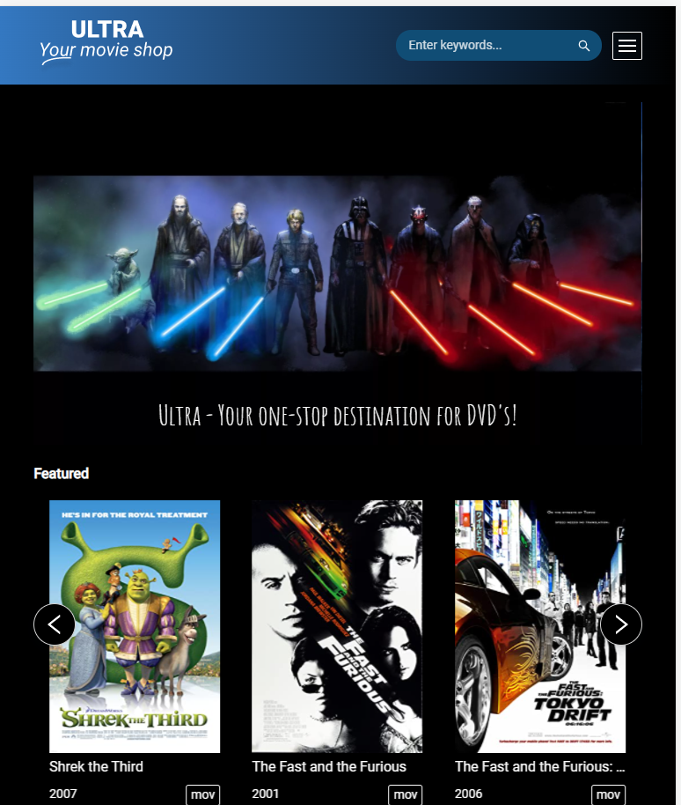

### Browse for movies or TV series

The user can click on “Movies” or “TV Series” links in the header to browse available titles:

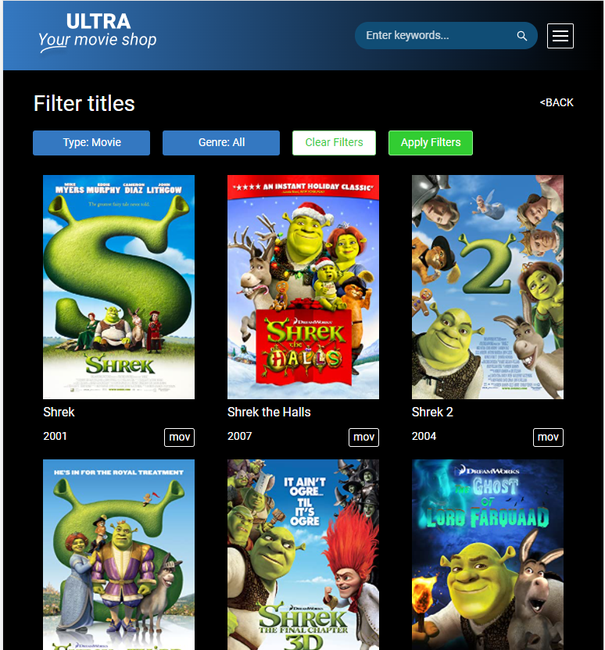

### Filtering titles

In the search page, there are 2 dropdowns: “Type” and “Genre” which the user can use to narrow down to the specific titles he/she prefers:

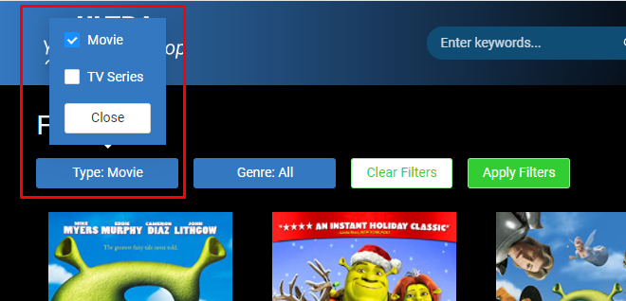

The Movie dropdown

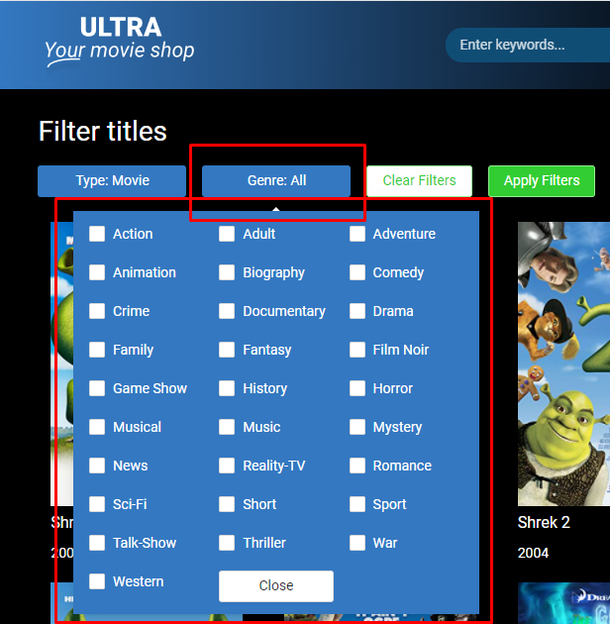

The Genre dropdown

User can simply choose some checkboxes and press “Apply filters” to narrow down the results.

### Searching by keyword

The user can search for a particular title by entering a keyword in the header (desktop view) or Query box (mobile view) and pressing “search”:

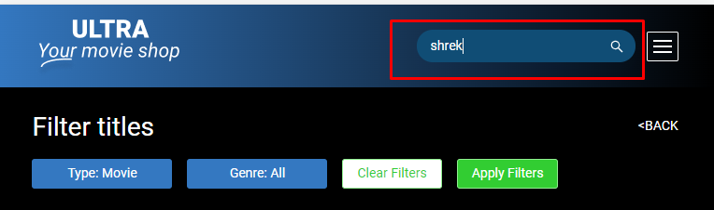

Desktop view

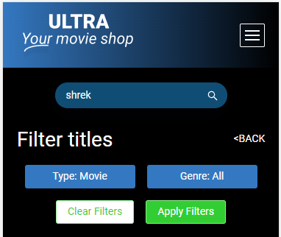

Mobile view

### Viewing title details

If a title is clicked, the user can then view the details such as actors, plot of the title:

